Part B - Project Management

Project Plan 2810ICT

Ben White – s2850345

Liam Preston – s5301986

Thomas Chapman – s5251549

Table of Contents

1.0 Introduction 3

1.1 Background 3

1.2 Scope 3

1.3 Document contents 3

2.0 Work Breakdown Structure 5

3.0 Activity Definition & Estimation 6

4.0 Gantt Chart 12

# Introduction

## Background

The Victorian government has collected road incident data from 2015 to 2020 to accurately analyse data to increase road safety within the state. This data set features a list of fatal and injury statistics which include specific details such as time, date, day, crash type, alcohol usage and other important data. This dataset can be a source of understanding crash occurrences and patterns and other factors that contribute to different types of vehicle incidents within the state of Victoria.

## Scope

Part A focuses primarily on the preparation of the project. Our group will take part in project planning, as well as software design documentation. The output will include an extensive project plan, a software design document and a detailed Gantt chart showing time estimations.

## Document contents

**Introduction**

In this section we introduce the background of the document in relation to the Victoria state road incident data, the scope of the project, and the document contents for Part A.

**Work breakdown structure**

The work breakdown structure diagram illustrates the necessary activities required for the project completion. Each section is broken down into the initial setup, planning, executing software development, controlling of the project, and finally the project conclusion.

**Activity definition & estimation**

In this segment, the activities listed in the WBS diagram have extra details including a description of each individual activity that will be undertaken, as well as an estimated duration.

**Gantt chart**

The Gantt chart is created to show a visualization of the WBS activities and their estimated time for completion. A separate Gantt chart will also be provided showing how long Part A took for the team to complete.

**System vision**

The part of the document specifies the long-term goals and objectives of the project for the software development plan. It paints a picture for the reader of this project of what the team wishes to accomplish with the software. It will give vision of how it will utilize the Victoria State dataset to analyse the impact it has on road incidents.

**Requirements**

This document outlines the functional and non-functional requirements for the project. It specifies the system is meant to do and how the team will use specific software requirements, data requirements and user interface requirements to meet the users' needs.

**Software design and system components**

This document includes a diagram of how our software will work when it is coded and implemented. It also includes a set of functions along with descriptions, input parameters, side effects and descriptions of return values for the project. Each primary function will be created around the analysis tools used with the Victoria Accident dataset. This section also includes the data structure and sources and how it will be used in the project. Finally, a detailed high-level design will include pseudocodes for all the standard and non-trivial algorithms.

**User interface design**

This section includes structural and visual user interface designs for the application. It specifies the style, colour, layout, fonts of each screen design as well as visual wireframe designs of each application screen. A description will be provided of how we got to the conclusion of each design, and why we included certain aspects of it.

# Updated Work Breakdown Structure

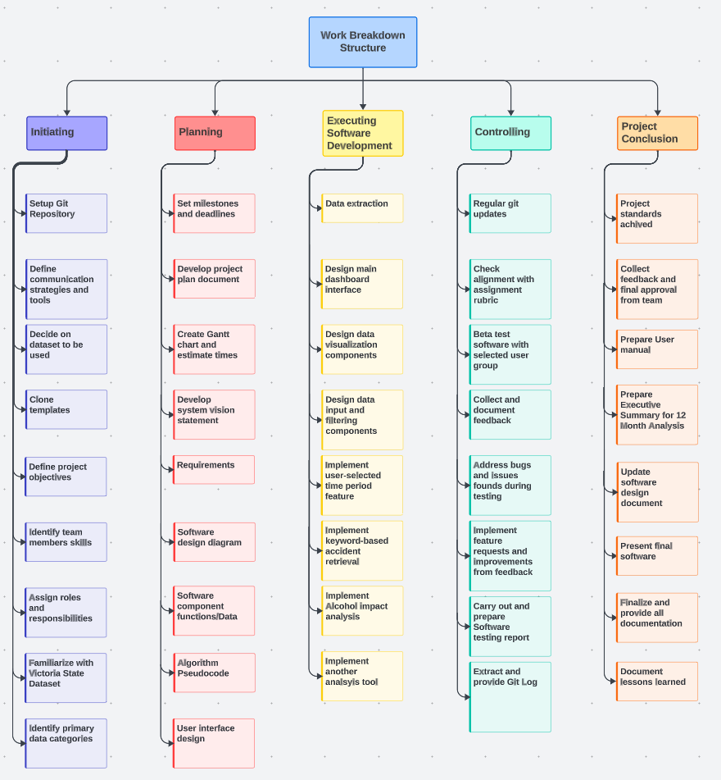

# Activity Definition & Estimation

**Initiating**

1.1 Setup Git Repository.

Description: The team will create a git repository for all the project documentation and code. We will also ensure all team members have the right permissions and permissions for the teaching staff to access our work.

Estimation Duration: 1 Hour

1.2 Define communication strategies and tools.

Description: The team will decide on the primary choice of communication for the project and how often discussions will take place.

Estimation Duration: 2 Hour

1.3 Decide on dataset to be used.

Description: The team will assess all the available datasets and pick what best interests the group.

Estimation Duration: 2 Days

1.4 Clone templates.

Description: The team will clone the repository on GitHub provided by the teaching team to use as a template for the Project plan and software design documentation.

Estimation Duration: 1 Hours

1.5 Define project objectives.

Description: The team will decide on project objectives once the dataset has been chosen.

Estimation Duration: 3 Hours

1.6 Identify team members based on skills and experience.

Description: The team will discuss skills and experience relevant to different sections of the project so we can split the work up effectively.

Estimation Duration: 2 Hours

1.7 Assign roles and responsibilities.

Description: The team will have roles and responsibilities assigned to them based on their skills.

Estimation Duration: 2 Hours

1.8 Familiarize with Victoria State Accident Dataset.

Description: The team as a group will go through the dataset to understand its different data columns and potential uses for the software design and implementation.

Estimation Duration: 2 Hours

1.9 Identify primary data categories and structures.

Description: The team will identify primary categories within the dataset for the accident analysis. This will help design the analysis techniques for the software design.

Estimation Duration: 1 Hour

**Planning**

2.1 Set milestones and deadlines.

Description: The team will identify key milestones that need to be met and set deadlines for each of them. This will provide us a timeline that we can follow effectively.

Estimation Duration: 2 Hours

2.2 Develop project plan document.

Description: The team will create the project plan and edit it as the project goes on with details and objectives as necessary. The document serves as a blueprint for the entire project.

Estimation Duration: 3 Weeks

2.3 Create Gantt chart and estimate times.

Description: The team will create a Gantt chart for the activities that are required for completion of the project along with time estimations. This will help us with a graphical view of the project.

Estimation Duration: 2 Days

2.4 Develop system vision statement.

Description: The team will create a vision statement that will outline the long-term goals and impact of the software project design.

Estimation Duration: 2 Days

2.5 Requirements.

Description: The team will outline the requirements for users and how they will use our program. This activity will also include software requirements along with use cases and diagrams.

Estimation Duration: 3 Days

2.6 Software design diagram.

Description: The team will create a diagram of how our software might work when we do Part B.

Estimation Duration: 2 Days

2.7 Software component functions/Data.

Description: The team will list and describe the functions and data components required for our software.

Estimation Duration: 5 Days

2.8 Algorithm Pseudocode.

Description: The team will develop pseudocode for the algorithms to guide our coding process. This will give a high-level overview of the logic to be done in Part B.

Estimation Duration: 2 Days

2.9 User interface design.

Description: The team will create sketches and wireframes of the user interface. This will give a visual layout and flow of our application.

Estimation Duration: 4 Days

**Executing Software Development**

3.0 Data extraction.

Description: The team will extract only the necessary data from the Victoria State Dataset while also cleaning it to make sure it is ready for implementation.

Estimation Duration: 2 Days

3.1 Design main dashboard interface.

Description: The team will design the dashboard for the application so that it is functional and pleasant to look at.

Estimation Duration: 2 Days

3.2 Design data visualization components.

Description: The team will design the data visualization components for the Accident analysis such as charts or graphs.

Estimation Duration: 1 Day

3.3 Design data input and filtering components.

Description: The team will design the data input and filtering components allowing the users to view accident data based on their parameter inputs.

Estimation Duration: 2 Days

3.4 Implement user-selected time feature.

Description: The team will code and implement the analysis feature allowing users to select specific time ranges for data visualization of the road accident.

Estimation Duration: 3 Days

3.5 Implement keyword-based accident retrieval.

Description: The team will code and implement the feature where users can search for specific accidents by keyword.

Estimation Duration: 3 Days

3.6 Implement Alcohol impact analysis.

Description: The team will code and implement a feature to analyse the impact of alcohol on accidents.

Estimation Duration: 3 Days

3.7 Research and implement another analysis tool.

Description: The team will research and implement another analysis tool that will provide insight into Victoria’s Road accidents.

Estimation Duration: 4 Days

**Controlling**

4.0 Regular git updates.

Description: The team will consistently update the Git with commits and pushes ensuring the project is up to date and all team members can see any project progression.

Estimation Duration: Whole duration of project – 10 Weeks

4.1 Check alignment with assignment rubric often.

Description: The team will check the assignment rubric often when working or during meetings to ensure we are doing the correct work required.

Estimation Duration: Whole duration of project – 10 Weeks

4.2 Beta test software with selected user group.

Description: The team will beta test software as it is being developed to ensure the user group is happy with the interface and overall design of the analysis tools.

Estimation Duration: 3 Weeks

4.3 Collect and document user feedback.

Description: The team will gather feedback from the users testing and document it so that we can improve on our Analysis software throughout the project.

Estimation Duration:

4.4 Address bugs and issues identified during beta testing.

Description: The team will address bugs found during beta testing and make the necessary changes to the code to improve the application.

Estimation Duration: 3 Weeks

4.5 Implement feature requests and improvements based on feedback.

Description: The team will implement feature requests and improvements based on the user feedback during testing.

Estimation Duration: 3 Weeks  
  
4.6 Carry out and prepare Software Testing Report.

Description: The team will compile all the testing scenarios, results, and coverage data into a comprehensive report.

Estimation Duration: 4 Days

4.7 Extract and Provide Git Log

Description: The git log will be extracted and provided as part of the documentation.

Estimation Duration: 1 Hour

**Project Conclusion**

5.0 Ensure all performance standards are achieved.

Description: The team will ensure all standards are kept to the same high level throughout the project by cross checking work with other team members.

Estimation Duration: Whole duration of project – 10 Weeks

5.1 Collect feedback and get final approval from team members.

Description: The team will collect feedback from one another towards the end of the project and gather internal feedback for the final approval of the project.

Estimation Duration: 5 Days

5.2 Prepare User Manual.

Description: The team will draft and finalize a user manual to guide users on how to use the developed software. This will include screenshots and feature explanations.

Estimation Duration: 4 Days

5.3 Prepare Executive Summary for 12-month Analysis.

Description: Using the software, an executive summary will be prepared covering the data analysis over a 12-month period, presenting results and insights.

Estimation Duration: 5 Days

5.4 Update Software Design Document.

Description: Based on the completed software, the software design document will be revised to match the final version of the software.

Estimation Duration: 2 Weeks

5.5 Present the final software.

Description: The completed project will be combed through and prepared for presentation to the teaching team.

Estimation Duration: 4 Days

5.6 Finalize and provide all project documentation.

Description: The team will finalize and provide all project documentation including code comments, a user guide and user feedback for the project.

Estimation Duration: 3 Days

5.7 Document lessons learned.

Description: The team will document lessons learned throughout the project which will include successes but also area that can be improved on.

Estimation Duration: 3 Hours

# Gantt Chart

Gantt image 1 represents our estimations for Part A and Part B, along with how long we estimated each activity to take. Gantt image 2 which is attacked to the assignment presents the actual time it took to complete all our activities throughout the project.

Gantt Image 1: Estimation

Gantt Image 2: Actual time